DIGITAL DISTRIBUTION AGREEMENT

BETWEEN THE UNDERSIGNED:

Afrobreakers Distribution (“Us”),

AND

(“You”),


Artist

Track(s) add multiple titles if

necessary

WHEREAS:

You own or control copyrights in sound recordings and music videos and wish to distribute these recordings and music videos digitally. We have built a large digital distribution network and wish to carry out the distribution of your recordings and music videos digitally. The purpose of this agreement (the “Agreement”) is to stipulate the terms and conditions of the digital distribution of your recordings and music videos by us. The terms of this agreement are:

Territory: The World

Royalty: 50% of Net receipts to us for the recording

Term: 5 years then automatic renewal for successive one-year terms unless terminated by either party upon three months notice to the other party.

Accounting: Quarterly (90 days) after the quarter in which the content was submitted, invoicing and payment within 1 (one) calendar month of sending the invoice. An example payment schedule is as follows.
- For content submitted from January to March, a statement will be sent the following July.
- For content submitted from April to June, a statement will be sent the following September.

- For content submitted from July to September, a statement will be sent the following January.
- For content submitted from October to December, a statement will be sent the following April.

Grant of Rights: you will irrevocably grant us the exclusive right to compile, manufacture, distribute, sell, stream, promote, advertise the recording, its artwork and its video.

Reserves: We are entitled to retain royalties up to a cap of 10% of sales, which shall be liquidated within 2 accounting periods of being taken

Publishing Collection and Royalty: We will collect your publishing earnings and will be entitled to 50% of Net receipts of collected publishing earnings.

Warranties: You warrant that

- you have the right to enter into and perform this agreement;
- neither the recordings nor the compositions embodied thereon shall infringe the rights of third parties;
- you grant to us and you shall procure that the artist and any featured artist grants to us all necessary performers consents and you waive and you shall procure that artist and any featured artist waives any and all moral rights in the recordings and the compositions embodied thereon

Special provisions: Use in streams / radio / TV soundbed. Use of Artist / Track name in all advertising. All 3rd Party samples must have appropriate clearance from Copyright owner(s).

Signed By

SIGNATURE______________________________

FULL NAME______________________________
Please also provide label copy per attached form.
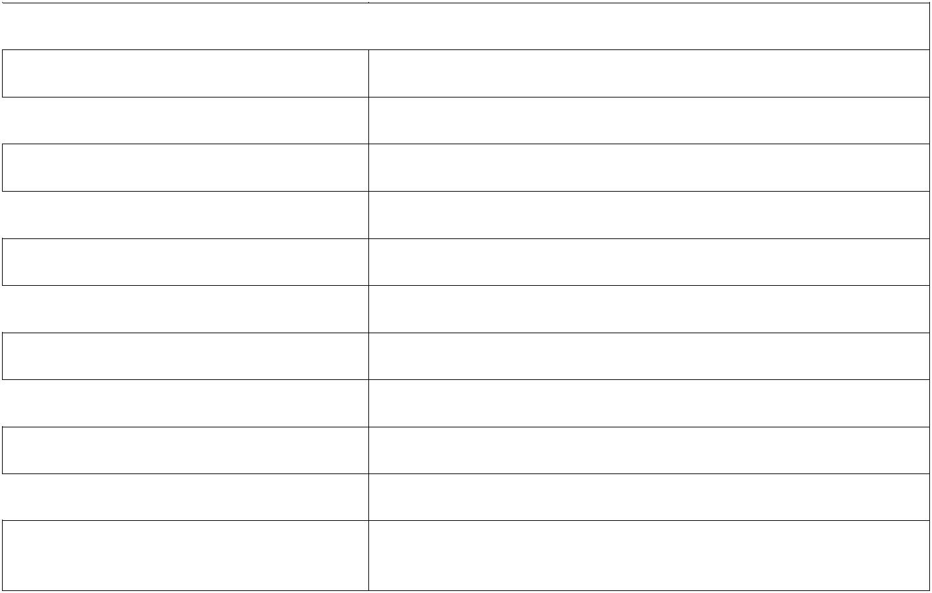

Contact Name

Email address

Phone Number
Address

City
Zip Code

Country
Signature Date

Written by
Published by

Produced by
(p) date & copyright owner (company):

PAYMENT INFORMATION
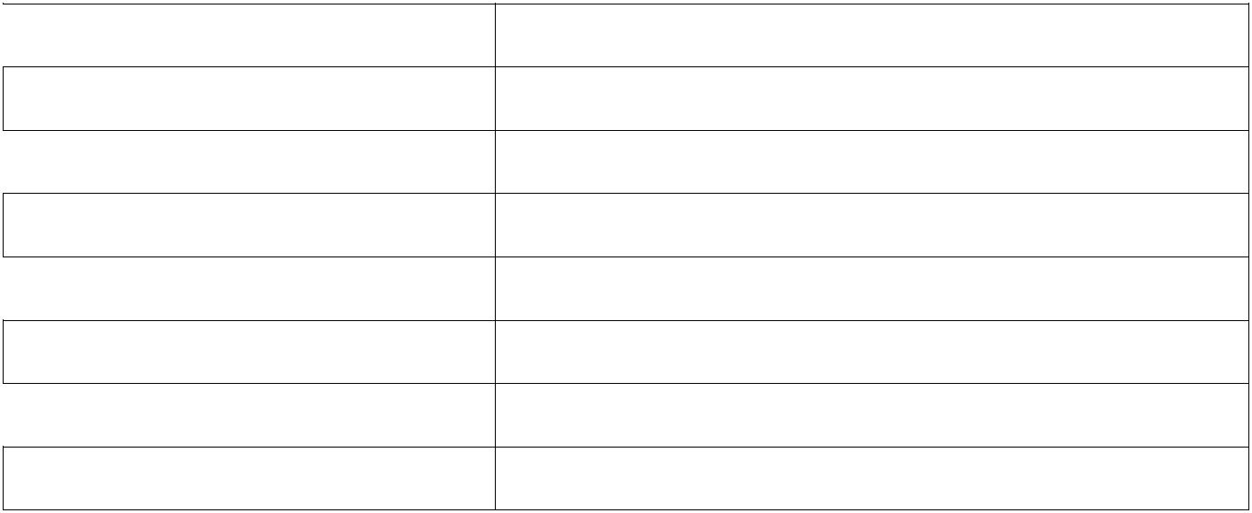

Account name
Bank name

Bank Address
Branch name

Beneficiary Account No
IBAN

BIC
SORT CODE

